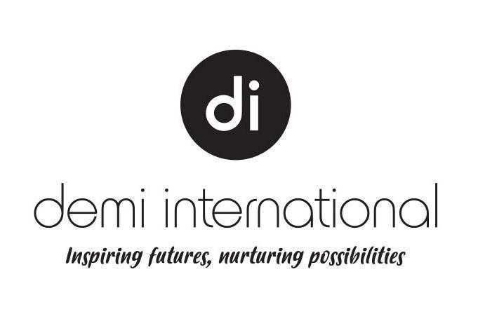
2024 FEE SCHEDULE
SHB50121 Diploma of Beauty Therapy
Demi International Beauty Academy
FULL TIME Intake B
VSL Cap: $18,097
January Intake B |  |  |  |  |  | Tuition Fees
Unit of Study | Codes | EFTSL | Commencement Date | Census Date | Completion Date | Full Fee | Non Concessional | Concessional
Diploma of Beauty Therapy Term 1, 2024 – Part 1/5 | DBFT1.5 | 0.2 | 4-Mar-2024 | 11-Mar -2024 | 8-Apr-2024 | $4,013.4 | $3,057.4 | $,2,770.6
Diploma of Beauty Therapy Term 2, 2024 – Part 2/5 | DBFT2.5 | 0.2 | 15-Apr-2024 | 29-Apr-2024 | 21-Jun-2024 | $4,013.4 | $3,057.4 | $,2,770.6
Diploma of Beauty Therapy Term 3, 2024 – Part 3/5 | DBFT3.5 | 0.2 | 8-Jul-2024 | 22-Jul-2024 | 13-Sep-2024 | $4,013.4 | $3,057.4 | $,2,770.6
Diploma of Beauty Therapy Term 4, 2024 – Part 4/5 | DBFT4.5 | 0.2 | 30-Sep-2024 | 14-Oct-2024 | 13-Dec-2024 | $4,013.4 | $3,057.4 | $,2,770.6
Diploma of Beauty Therapy Term 1, 2025 – Part 5/5 | DBFT5.5 | 0.2 | 28-Jan-2025 | 10-Feb-2025 | 4-Apr-2025 | $4,013.4 | $3,057.4 | $,2,770.6

October Intake B
Unit of Study | Codes | EFTSL | Commencement Date | Census Date | Completion Date | Full Fee |  | Non Concessional | Concessional
Diploma of Beauty Therapy Term 2, 2024 – Part 1/5 | DBFT1.5 | 0.2 | 25-May-2024 | 30-Apr-2024 | 1-Jul-2024 | $4,013.4 | $3,057.4 |  | $,2,770.6
Diploma of Beauty Therapy Term 3, 2024 – Part 2/5 | DBFT2.5 | 0.2 | 8-Jul-2024 | 22-Jul-2024 | 13-Sep-2024 | $4,013.4 | $3,057.4 |  | $,2,770.6
Diploma of Beauty Therapy Term 4, 2024 – Part 3/5 | DBFT3.5 | 0.2 | 30-Sep-2024 | 14-Oct-2024 | 13-Dec-2024 | $4,013.4 | $3,057.4 |  | $,2,770.6
Diploma of Beauty Therapy Term 1, 2025 – Part 4/5 | DBFT4.5 | 0.2 | 28-Jan-2025 | 10-Feb-2025 | 4-Apr-2025 | $4,013.4 | $3,057.4 |  | $,2,770.6
Diploma of Beauty Therapy Term 2, 2025 – Part 5/6 | DBFT5.5 | 0.2 | 22-Apr-2025 | 5-May-2025 | 27-Jun-2025 | $4,013.4 | $3,057.4 |  | $,2,770.6

July Intake B
Unit of Study | Codes | EFTSL | Commencement Date | Census Date | Completion Date | Full Fee |  | Non Concessional | Concessional
Diploma of Beauty Therapy Term 3, 2024 – Part 1/5 | DBFT1.5 | 0.2 | 19-Aug-2024 | 26-Aug-2024 | 23-Sep-2024 | $4,013.4 | $3,057.4 |  |  | $,2,770.6
Diploma of Beauty Therapy Term 4, 2024 – Part 2/5 | DBFT2.5 | 0.2 | 30-Sep-2024 | 14-Oct-2024 | 13-Dec-2024 | $4,013.4 | $3,057.4 |  |  | $,2,770.6
Diploma of Beauty Therapy Term 1, 2025 – Part 3/5 | DBFT3.5 | 0.2 | 28-Jan-2025 | 10-Feb-2025 | 4-Apr-2025 | $4,013.4 | $3,057.4 |  |  | $,2,770.6
Diploma of Beauty Therapy Term 2, 2025 – Part 4/5 | DBFT4.5 | 0.2 | 22-Apr-2025 | 5-May-2025 | 27-Jun-2025 | $4,013.4 | $3,057.4 |  |  | $,2,770.6
Diploma of Beauty Therapy Term 3, 2025 – Part 5/5 | DBFT5.5 | 0.2 | 14-Jul-2025 | 28-Jul-2025 | 19-Sep-2025 | $4,013.4 | $3,057.4 |  |  | $,2,770.6

October Intake B
Unit of Study | Codes | EFTSL | Commencement Date | Census Date | Completion Date | Full Fee |  | Non Concessional | Concessional
Diploma of Beauty Therapy Term 4, 2024 – Part 1/5 | DBFT1.5 | 0.2 | 11-Nov-2024 | 18-Nov-2024 | 16-Dec-2024 | $4,013.4 | $3,057.4 |  |  | $,2,770.6
Diploma of Beauty Therapy Term 1, 2025 – Part 2/5 | DBFT2.5 | 0.2 | 28-Jan-2025 | 10-Feb-2025 | 4-Apr-2025 | $4,013.4 | $3,057.4 |  |  | $,2,770.6
Diploma of Beauty Therapy Term 2, 2025 – Part 3/5 | DBFT3.5 | 0.2 | 15-Apr-2024 | 22-Apr-2025 | 5-May-2025 | $4,013.4 | $3,057.4 |  |  | $,2,770.6
Diploma of Beauty Therapy Term 3, 2025 – Part 4/5 | DBFT4.5 | 0.2 | 8-Jul-2024 | 14-Jul-2025 | 28-Jul-2025 | $4,013.4 | $3,057.4 |  |  | $,2,770.6
Diploma of Beauty Therapy Term 4, 2025 – Part 5/5 | DBFT5.5 | 0.2 | 7-Oct-2025 | 20-Oct-2025 | 12-Dec-2025 | $4,013.4 | $3,057.4 |  |  | $,2,770.6

